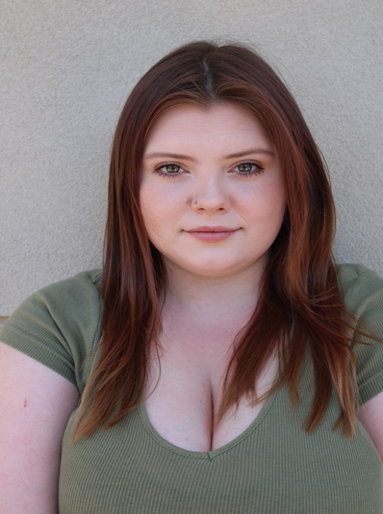
Haylie Auburn Collins

Voice Part: Soprano (678) 215-3685
(E3 – G6) Height: 5’2”
haylieacollins@gmail.com Weight: 200 lbs.
Birthdate: 03/13/2003

Acting Experience:
9 to 5 Doralee Rhodes Piedmont University
RENT Maureen Piedmont University
Steel Magnolias Ouiser Boudreaux Piedmont University
A Piece of My Heart Sissy Piedmont University
Laramie Project Various Piedmont University
Bright Star Edna Piedmont University
Valley Voices Mary Greene Hardman Farms
You Are Not Your Face Mira Lavender Fest
Technical Experience:
Godspell Choreographer Piedmont University
Rumors Stage Manager Piedmont University
RENT Assistant Stage Manager/Dance Captain Piedmont University
Hair Assistant Stage Manager Piedmont University
A Piece of My Heart Master Seamstress Piedmont University
Brother Bear Assistant Director Piedmont University
Dandelion Costume Designer Piedmont University
Training:
Vocal Training Joshua Devane Piedmont University
Blood Guts & Gore Masterclass John Spiegel Piedmont University
Costume Design Class John Spiegel Piedmont University
Special Skills:
Georgia State Driver’s License, Sight-reading, Vocal Sound Effects, hip hop dance for nine years, basic jazz, basic tap, basic modern

